Math 4 Name ___________________________

**2-2 Properties of Matrices** Date_____

Learning Goals:

* *I can determine if matrix multiplication is possible and determine the dimensions of the resulting matrix.*
* *I can multiply two matrices by hand.*
* *I can multiply two matrices using the graphing calculator.*
* *I can use matrix multiplication to solve real-life scenario problems.*
* *I can identify properties of matrices and compare them to those of the real numbers.*

I. **Matrix Multiplication**

1. There are two types of multiplication for matrices: **scalar multiplication** and **matrix multiplication**. In lesson 2-1 you learned about scalar multiplication, which is very straightforward as well as simple to perform. Multiplying a matrix times another matrix is a different story…..

Study the examples below and answer the questions that follow:

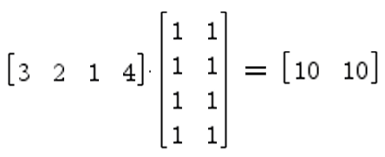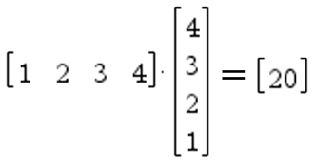

1. b.

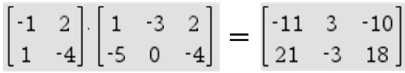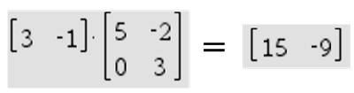

c. d.

* What do you notice about the resulting product matrices? What you end up with seems kind of random, perhaps. Not exactly. Go back and identify the orders for the two matrices being multiplied and their product.

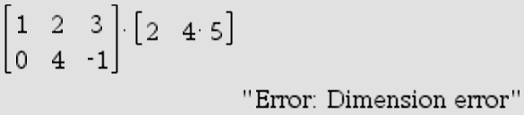

These two matrices cannot be multiplied:

* Based on the matrices’ orders, what must be true for them to be compatible for multiplying?
* How can you predict what the order of the product matrix will be?

Put your new theory to work:

3 X 8 times a 8 X 5 = ____ X ____ 10 X 3 times a 3 X 10 = ____ X ____

10 X 3 times a 10 X 3 = ____ X ____

Page 2

B. Now that you have the whole compatibility idea down, let’s see how the process of multiplying two matrices works. Revisit the multiplication problem below:

\*\*\**Matrix multiplication actually involves not just multiplying, but adding as well!*



Show how this process works for this example.



Show how this process works for this example.

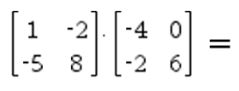

Now try this on your own:

*Show your work here:*

Check your final answer using your calculator. ☺

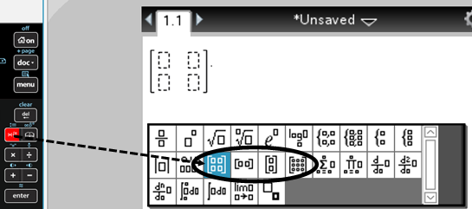

***Just for fun . . . . Try checking your answer to the example by dividing your product matrix by one of the***

***factors (in your calculator). What happens?***

Page 3

II. **Properties of Matrices**

There are several properties of the ***real numbers*** that you must remember in order to investigate the properties of matrices.

The first property is called the **commutative property of addition/multiplication**, which says  and . Show that this property is true (show addition for #1 and multiplication for #2) using the given *a* and *b* values:

1.  2. 

3. Is this property true for subtraction and/or division? Show yes or no using the *a* and *b* values from

number (1).

The second property is called the **associative property of addition/multiplication**, which says  and. Show that this property is true (show addition for #1 and multiplication for #2) using the given *a*, *b*, and *c* values.

4.  5. 

6. Is this property true for subtraction and/or division? Show yes or no using the *a*, *b*, and *c* values from number (4).

We are now going to explore whether or not these two properties hold for ***matrices***. Use the matrices below and your calculator to answer questions 7 – 14.

Let  ,  , and  .

7. Does the **commutative property of addition** hold for matrices? That is, does

Show yes or no below.

Page 4

8. Does the **commutative property of multiplication**hold for matrices? That is, does 

Show yes or no below.

9. Does the **associative property of addition** hold for matrices? That is, does  Show yes or no below.

10. Does the **associative property of multiplication**hold for matrices? That is, does  Show yes or no below.

Now, we will go back to the ***real numbers*** and explore a few more properties. The first is the fact that,

for numbers, there is both an **additive identity** and a **multiplicative identity.**

11. An **additive identity** is a number that you can add to *any number* without changing it. What is the additive identity? Think, *a + ____ = a.* The number that goes in the blank is the additive identity.

12. A **multiplicative identity** is a number that you can multiply by *any number* without changing it. What is the multiplicative identity? Think . The number that goes in the blank is the multiplicative identity.

13. Using matrix *B*, find the **additive identity matrix**. That is, fill in the blank with a matrix so that the



following statement is true:

14. Using matrix *A*, find the **multiplicative identity matrix**. That is, fill in the blank with a matrix so that



the following statement is true: This is a bit more challenging . . . .

The last property we will talk about is the **additive inverse** and the **multiplicative inverse**. An additive

inverse is a number that, when you add it to *a*, the sum is the additive identity. A multiplicative inverse

is a number that, when you multiply it by *a*, the product is the multiplicative identity.

What is the additive inverse of 7? _______ What is the multiplicative inverse of 7? _______

What is the additive inverse of *x*? _______ What is the multiplicative inverse of *x?* _______

*We will discuss as a class additive and multiplicative inverses of matrices.*

Page 5

Summary of Properties

|  |  |  |
| --- | --- | --- |
| **Properties** | **Real Numbers**  ***Yes or No*** | **Matrices**  ***Yes or No*** |
| Commutative Property of Addition |  |  |
| Commutative Property of Subtraction |  |  |
| Commutative Property of Multiplication |  |  |
| Commutative Property of Division |  |  |
| Associative Property of Addition |  |  |
| Associative Property of Subtraction |  |  |
| Associative Property of Multiplication |  |  |
| Associative Property of Division |  |  |
| **Properties** | **Real Numbers**  ***What is it?*** | **Matrices**  ***What is it?*** |
| Additive Identity |  |  |
| Multiplicative Identity  *Identity matrices are always _________.* |  |  |
| Additive Inverse |  |  |
| Multiplicative Inverse  *Not all matrices have inverses. Ones that do are _________ matrices.* |  |  |

**NOTES:**

Additive Inverse for Matrices:



Multiplicative Inverse for Matrices:

 = 

Complete:  *  = 

Given . Find .

**Lesson 2-2 Homework**  Page 6

Use the following matrices for problems 1 – 4.

   

1. Perform the following operations by hand (*if possible*). Show your work.

*A*B*

*C*D*

*B*A*

2. Which matrix does not have an inverse? ________

3. Which matrix is the multiplicative identity matrix? ________

4. Matrix *E* (not shown above) is multiplied by matrix *B* so that  produces a 4 x 3 matrix. What are the dimensions of matrix *E?* _________

\*\*\****Use your calculator for the remaining problems.***

5. Ralph and Trixie both run *ebay* businesses out of their parents’ homes. They both need to buy some

new DVDs and an *X-Box* 360 game to sell. The matrix below indicates the prices from two different stores for the desired items. They both want to shop at only one store, but they do not need to shop at the same store.

Ralph needs to buy 3 *Frozen* DVDs, 4 *Ted 2* DVDs, and 12 *Maddens*. Trixie needs to buy 5 *Frozen* DVDs, 1 *Ted 2* DVD, and 10 *Maddens*. Set up a matrix that represents this information. ***Be sure that the matrix can be multiplied by the cost matrix.***

a.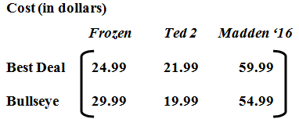

b. Multiply the Cost matrix and your matrix from part a. Show all 3 matrices. Be sure to label the

rows and columns all 3 matrices! Write your matrix equation below.

Page 7

c. Identify the meaning of the entry in the first row, first column of your solution matrix. ***Be specific!***

d. At which store should each person shop? ***Explain.***

6. Solve the following equation for matrix *X*.



7. Let matrices *A* and *B* be of orders  respectively. Answer the following questions and explain your reasoning.

a. Is it possible that *A* = *B*?

b. Is *A* + *B* defined?

c. Is *AB* defined? If so, is it possible that *AB* = *BA*?